**WEEK – 6**

**REACT**

1. **ReactJS – HOL:**

Following the steps mentioned in the handson, the output has been obtained as follows:

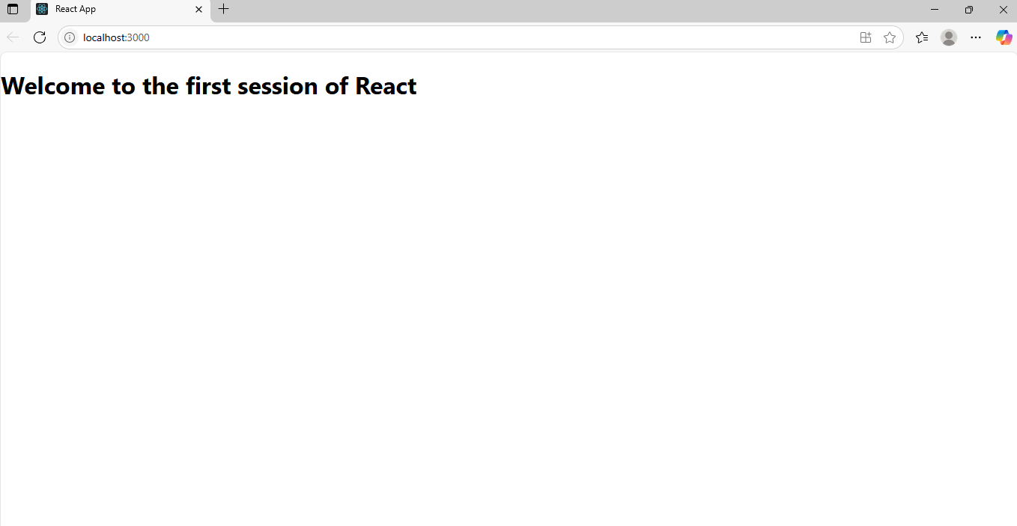

1. **ReactJS – HOL:**

The output for the handson is obtained as:

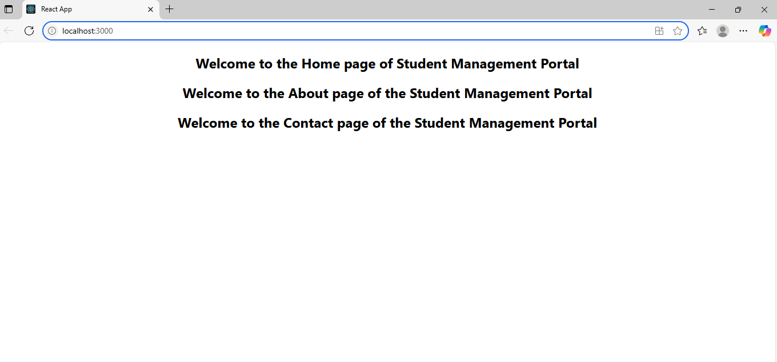

1. **ReactJS – HOL:**

The output for this activity is obtained as follows:

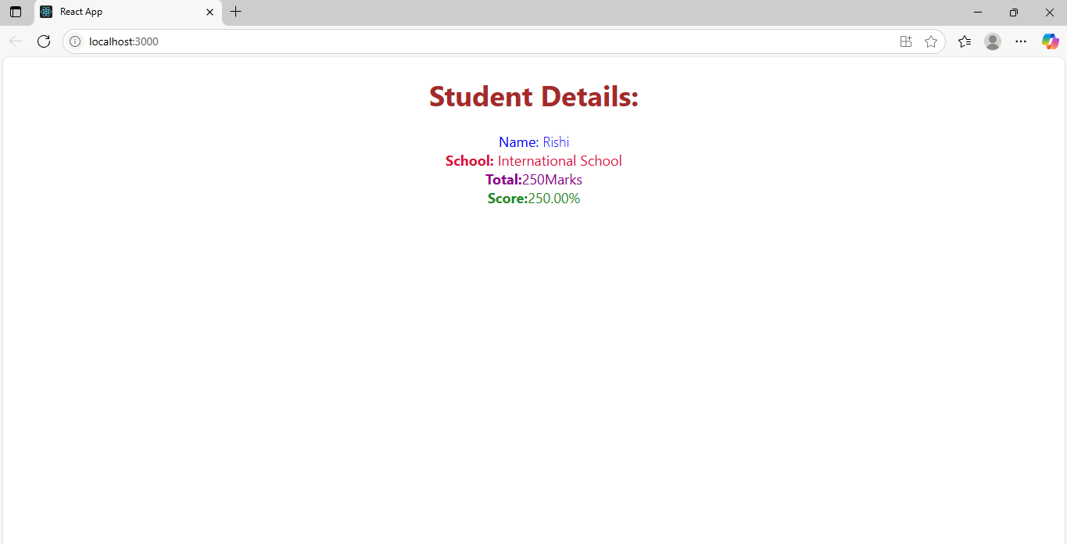

1. **ReactJS – HOL:**

The output for the handson after following all these steps is obtained as below:

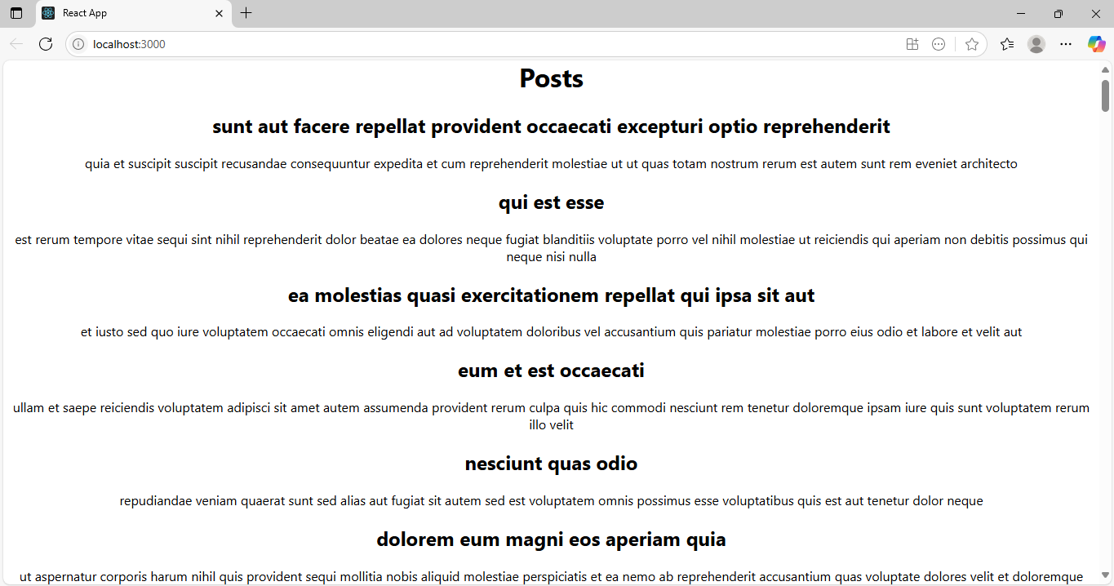

1. **ReactJS – HOL:**

**“Issue with the hanson”**

**The handson in file “5.ReactJS-HOL” does not contain any “cohorttracker” file. Thus, I couldn’t complete this hanson.**